CLASSIFICATION

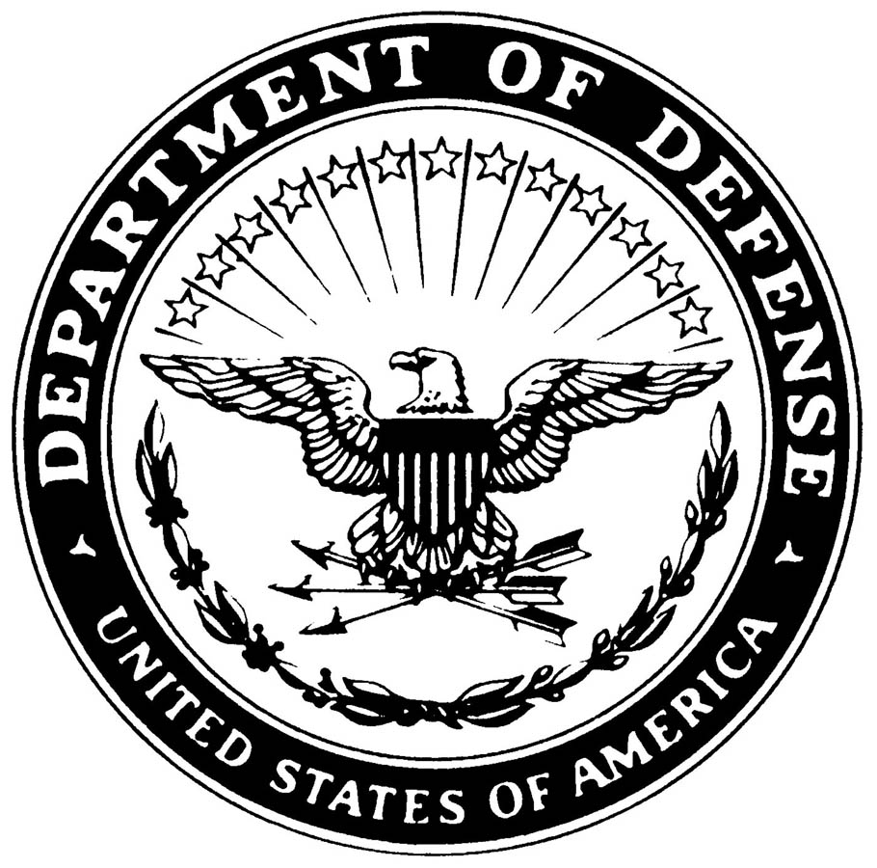

**UNITED STATES MARINE CORPS**

MARINE AIR GROUND TASK FORCE TRAINING COMMAND

MARINE CORPS AIR GROUND COMBAT CENTER

BOX 788100

TWENTYNINE PALMS, CALIFORNIA 92278-8100

SSIC

ORG CODE

(Date)

INFORMATION PAPER

Subj: FORMAT FOR AN INFORMATION PAPER (WRITTEN IN ALL CAPS)

1. Purpose: Why is the information being provided?

2. Key Points

* Use these papers to convey information for the reader’s use in

preparing for a meeting or briefing.

* Present facts and use clear, concise wording.
* Tick and bullet format is preferred. Use key words and phrases.
* General format is not as important as content.
* Tailor the paper to fit the need.
* Convey information the audience (usually a principal) would need to

know if being introduced to the subject issue or meeting for the first time.

* Address objectives the reader or the participants may have for the

meeting.

* Alert the reader to potential trouble areas.
* Identify hidden agendas.
* A length of one page is preferred. Two pages is the maximum.
* If the meeting is one-on-one with someone the reader does not know,

attach a biographical sketch.

Prepared by: I. M. MOTIVATOR, Capt, USMC

Agency, Section, Phone Number

CLASSIFICATION